# Git Assignment 2

## Github link: <https://github.com/shaileshdarji1/Java-Application-2>

## Create a branch from the master branch and make changes and commit changes.

* Here first we create empty repository using init command
* Create Demo2.java File
* Add to this file in staging area
* Commit this file
* Create Repository on github for push our code.
* Make Connection between local repository and Remote Repository using git remote add command.
* Push our code on github
* Create Another branch name is branch1.
* Switch to branch1.
* Make some changes in Demo2.java file
* Add this file in staging area.
* Commit Demo2.java
* Push on github

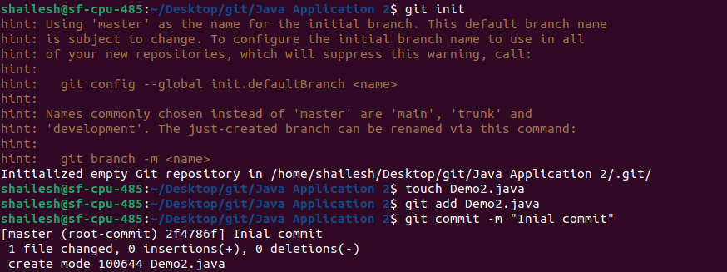

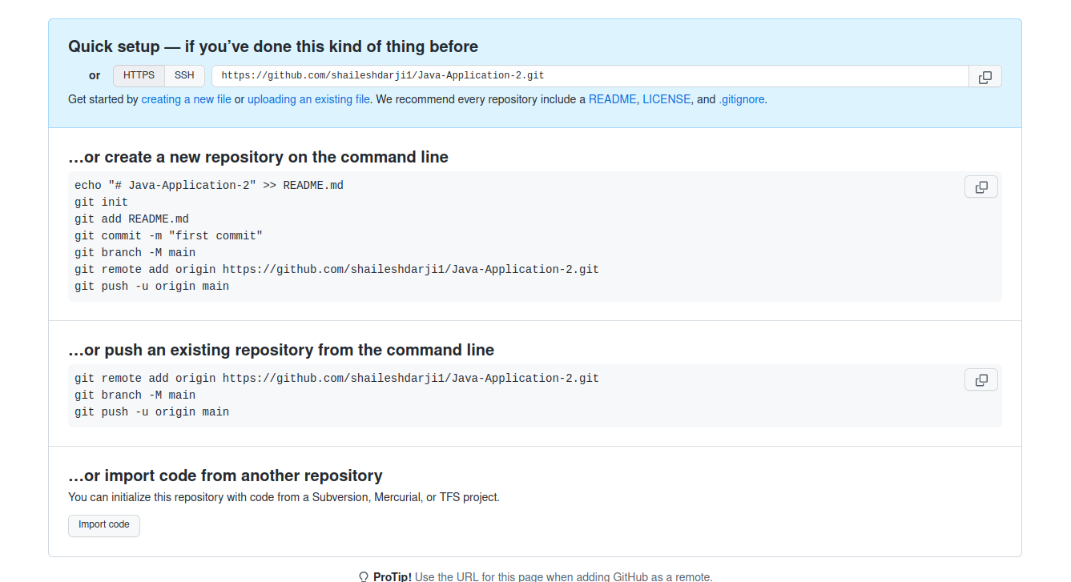

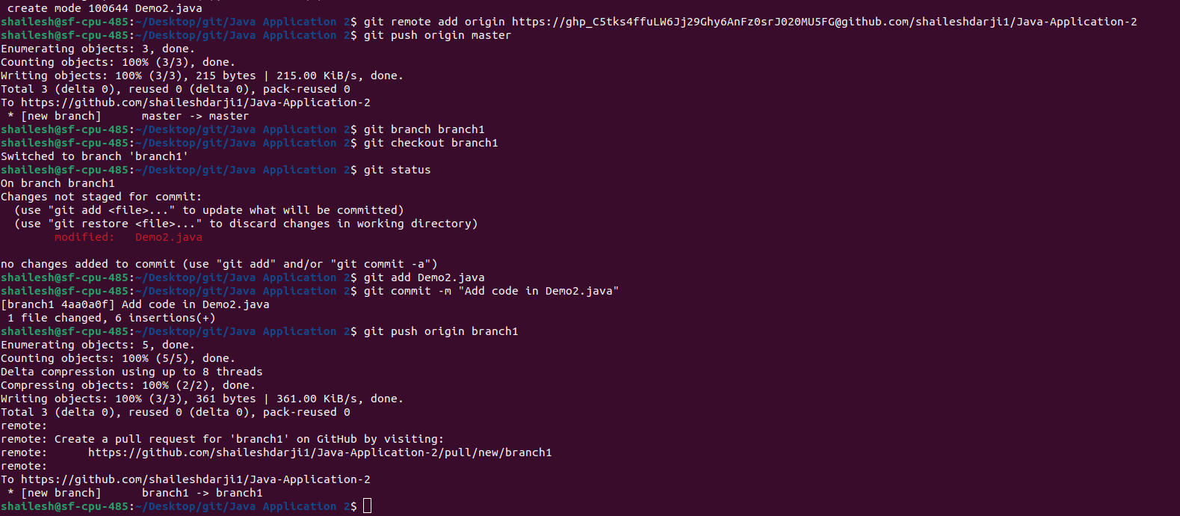

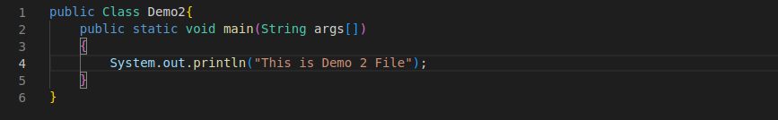

## Create a new branch from the master.

* Switch to our master branch using ‘git checkout master’
* Create new branch name branch2 using ‘git branch branch2’
* Show all the branch using ‘git branch’ command.

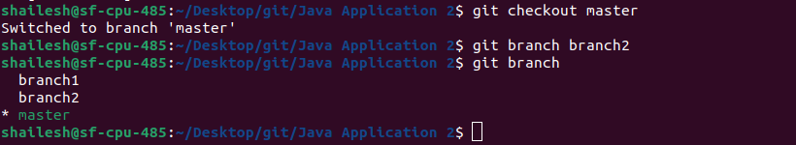

## Create a pull request for the first branch and merge it to the master.

* After push new branch with changed file.We see notification in github ‘compare and pull request’ click on it
* Here see the option of create pull request,click on it(If you have to make some changes in message you can)
* Next Page show merge pull request,click on it and merge out new-branch with our master branch.
* At,We receive confimation message.

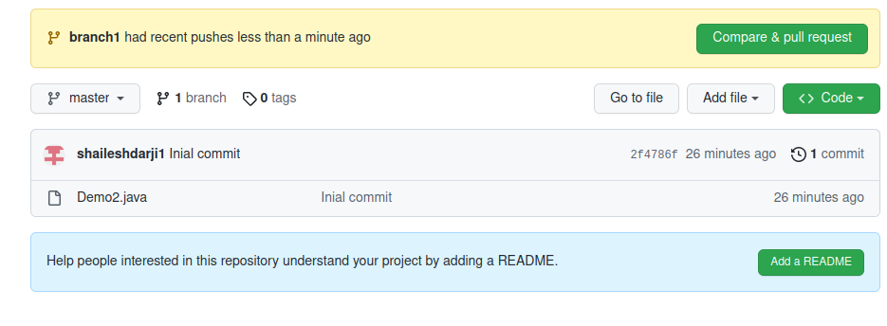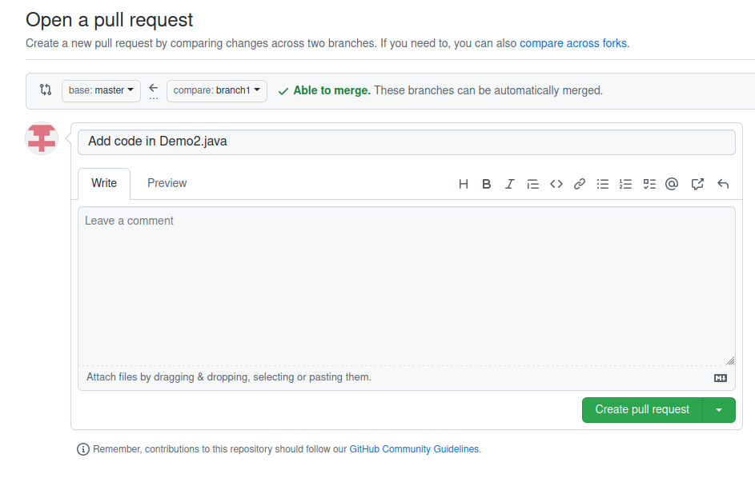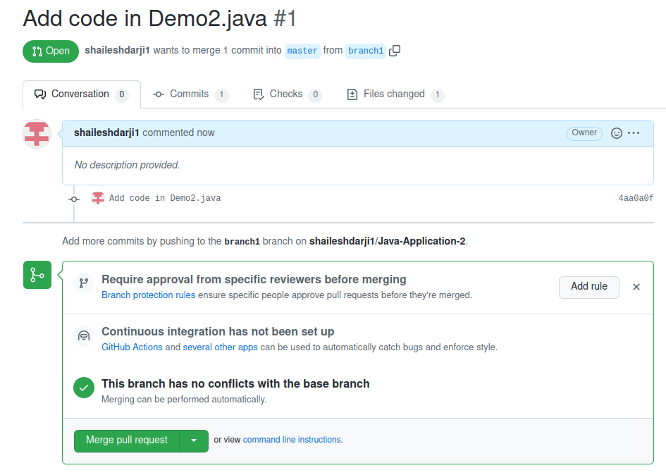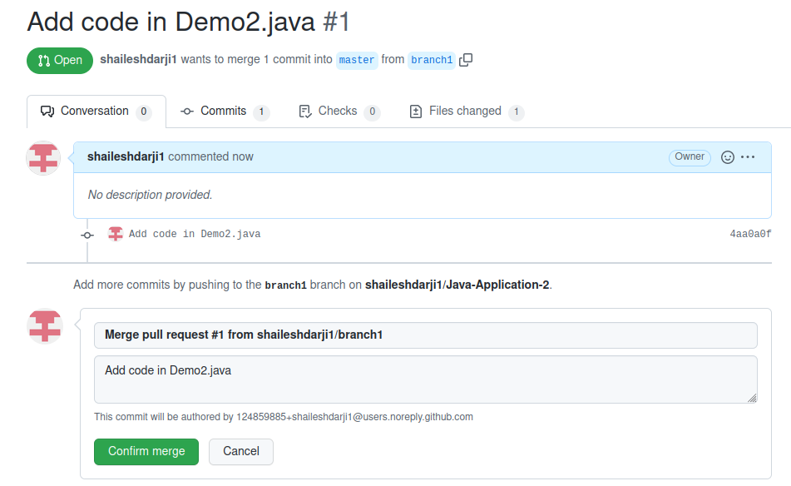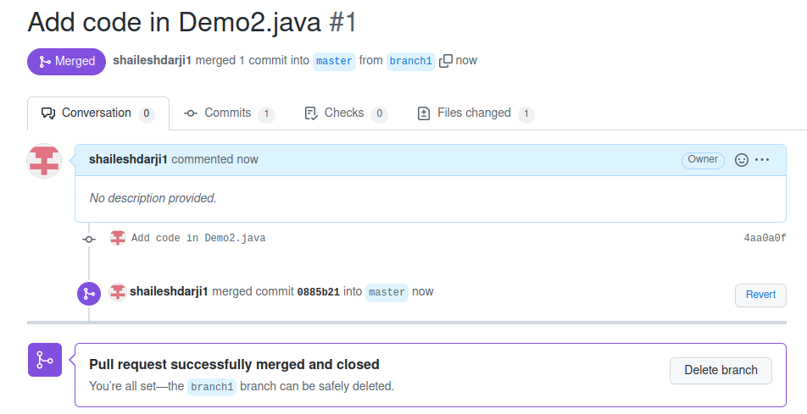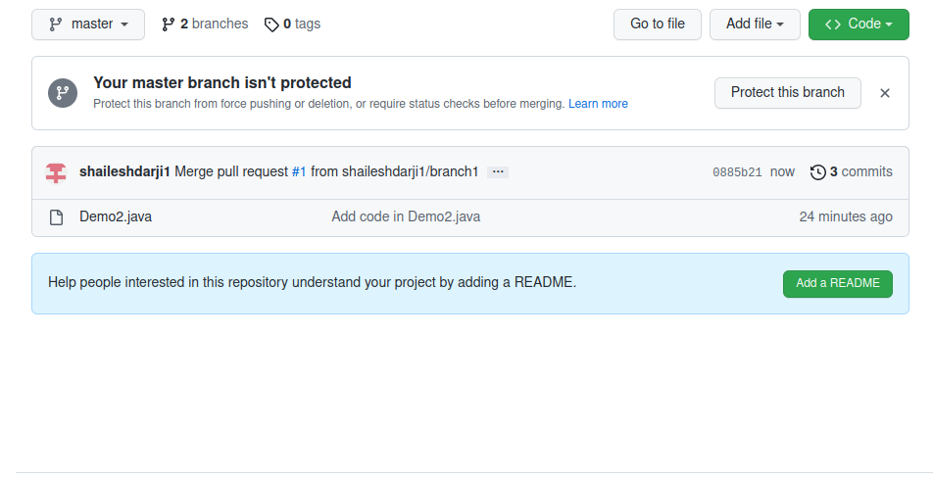

## Rebase the second branch with the master branch and make changes in the second branch and commit changes.

* Rebase is one of two Git utilities designed to integrate changes from one branch onto another. Rebasing is the process of combining or moving a sequence of commits on top of a new base commit. Git rebase is the linear process of merging.
* We merge branch1 and master at remote location but these changes not updated at our local repository.so first get these changes using ‘git pull orign master’
* switch to second branch and rebase with master using ‘git rebase master’
* Make some changes in Demo2.java
* Add to this file staging area
* Commit these file and push on github.

